Design Using UML

(Class Diagram & Sequence Diagram)

for

**Sistem Generate Akun Wifi Id**

Prepared by

171022000011 – Denis Setianto

171022000072 – Diany Anugrah Maulidya

23-04-2018

1. ***Class Diagram***

Berikut adalah gambaran *class diagram* Sistem Generate Akun Wifi ID

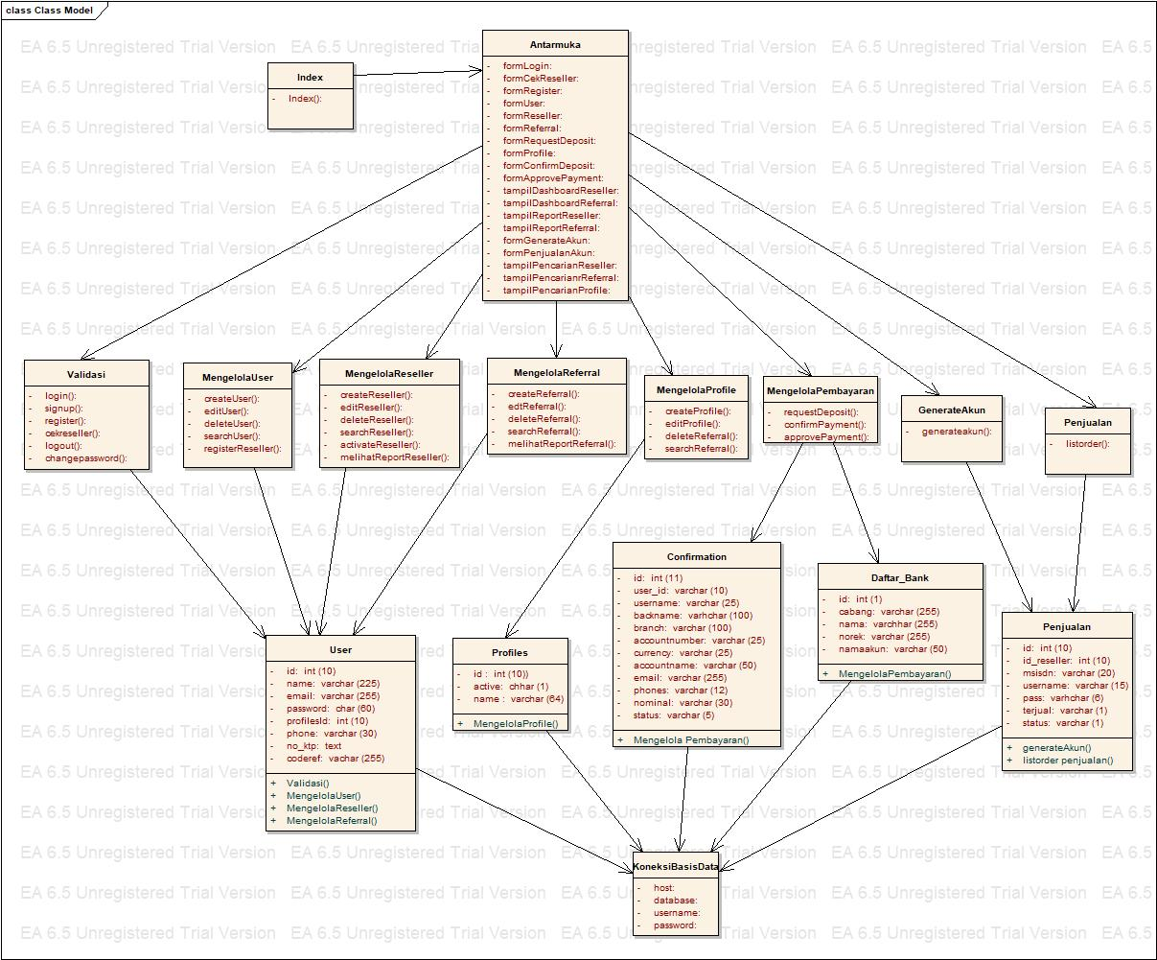

1

1

1

1

1

1

1

1

1

1

1

1

1

1

1

1

1

1

1

1

1

1

1

1

1

1

1

1…*

1

1

1

1

1

1

1…*

1…*

1…*

1…*

1…*

1…*

1…*

1. ***Sequence Diagram***

Berikut adalah gambaran *sequence diagram* Sistem Generate Akun Wifi Id

* 1. Sequence Diagram Login

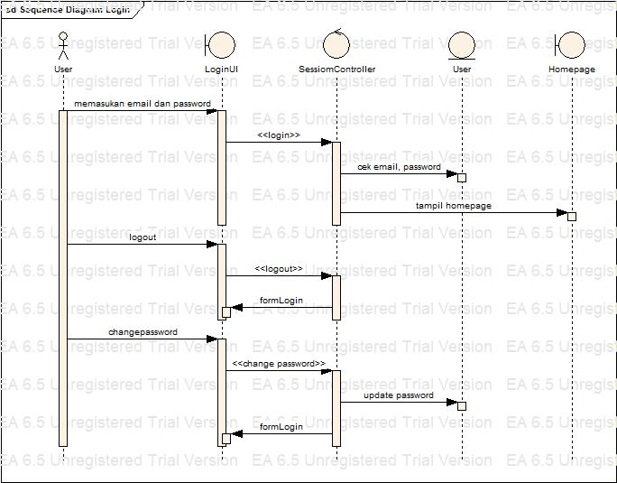

* 1. Sequence Diagram Register

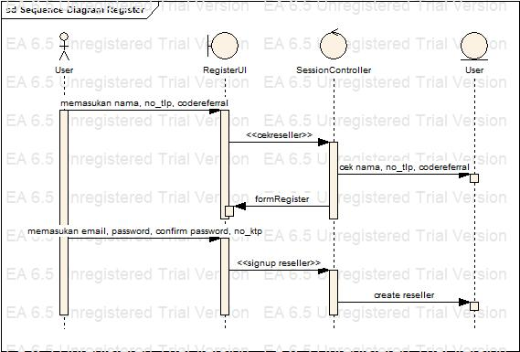

* 1. Sequence Diagram Kelola Data User

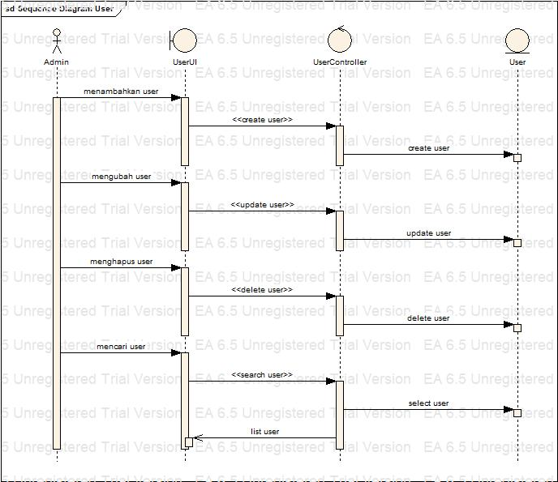

* 1. Sequence Diagram Kelola Data Profile

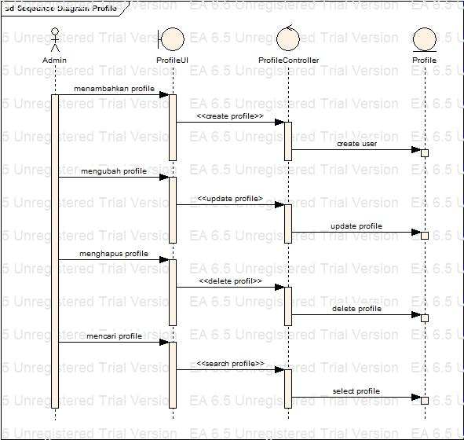

* 1. Sequence Diagram Kelola Data Reseller

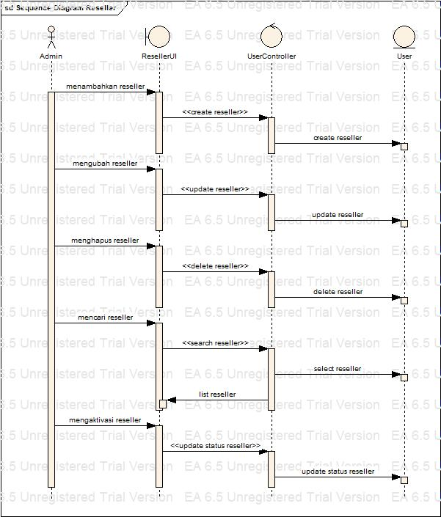

* 1. Sequence Diagram Kelola Data Referral

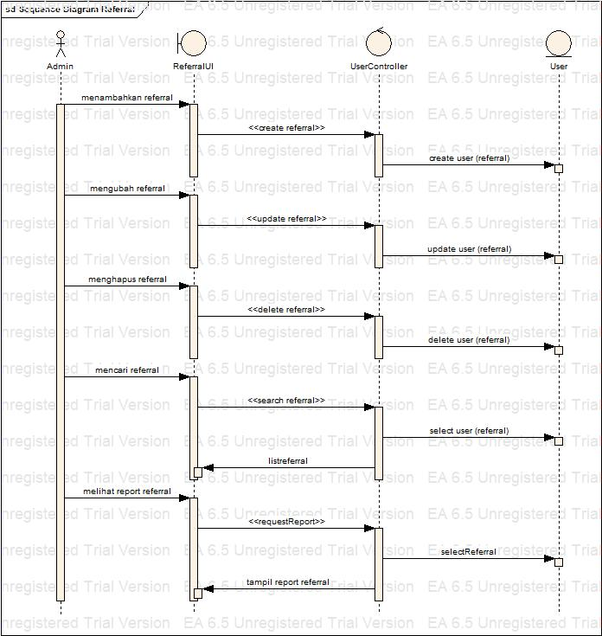

* 1. Sequence Diagram Request Deposit

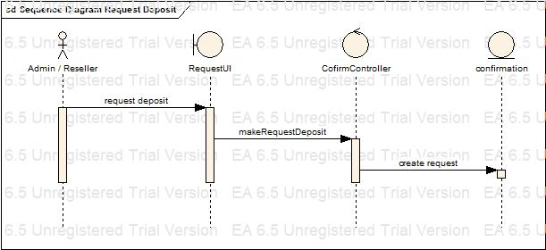

* 1. Sequence Diagram Confirm Payment

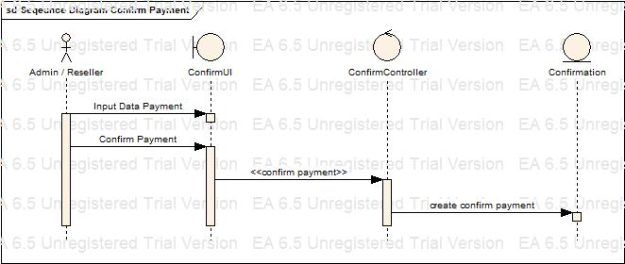

* 1. Sequence Diagram Approve Payment

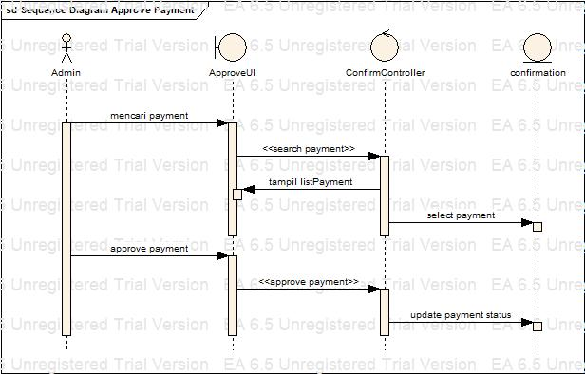

* 1. Sequence Diagram Generate Akun

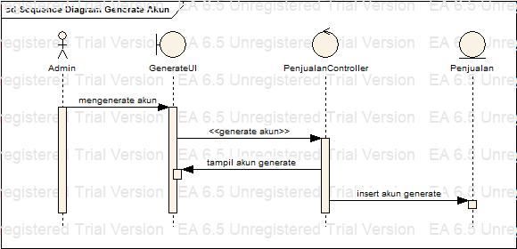

* 1. Sequence Diagram Penjualan Akun

